13.63: The maximum acceleration of both blocks, assuming that the top block does not slip, is 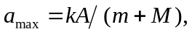 and so the maximum force on the top block is

